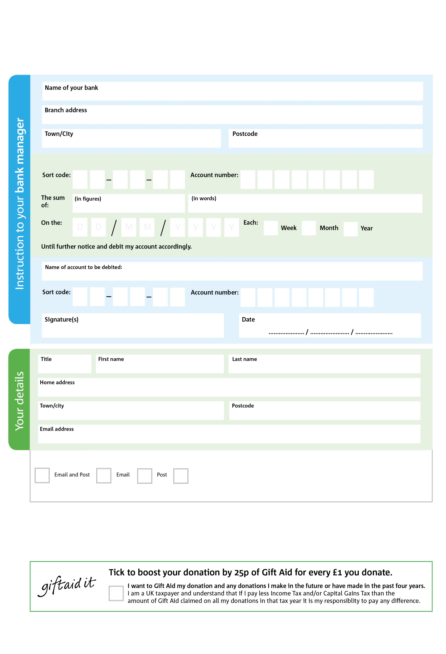

Reg. Charity No: 1185143 | Reg. in England & Wales

Please pay Farnworth & Kearsley Foodbank,

POSTAL ADDRESS: Farnworth & Kearsley Foodbank, The Well, Trafford Street, Farnworth, Bolton, BL4 7PQ

3

V

8

V

9

V

0

V

3

V

7

V

0

V

2

V

**Please pass this form onto the foodbank, using the foodbank’s address at the bottom, who will save a copy for their records.   
They will then send it onto your named bank or building society.**

7

7

2

0

5

0

We would love to keep you up to date with information about Farnworth & Kearsley Foodbank. Please tick your preference:

You can change your preferences any time by contacting us on 01204 861671 or emailing us at info@farnworthkearsley.foodbank.org.uk

I do not wish to receive future communications from Farnworth & Kearsley Foodbank

**Data protection**

*'Farnworth & Kearsley Foodbank is committed to protecting your privacy and will process your personal data in accordance with current Data Protection legislation. Farnworth & Kearsley Foodbank collects information to keep in touch with you and supply you with information relating to our work. To unsubscribe from our newsletter, send a message to the email address above with the word unsubscribe in the subject line. A full data privacy statement for financial donors is available from the foodbank on request.’*

**Standing Order Mandate**

**farnworthkearsley.foodbank.org.uk**

You can change your preferences any time by contacting us on XXXXXXXXXXX or emailing us at XXXX@XXXXXXXXXX.foodbank.org.uk

I do not wish to receive future communications from XXXXXX Foodbank