­

I want to Gift Aid my donation and any donations I make in the future or have made in the past 4 years to Farnworth and Kearsley Foodbank. I am a UK taxpayer and understand that if I pay less Income Tax and/or Capital Gains Tax than the amount of Gift Aid claimed on all my donations in that tax year it is my responsibility to pay any difference.



Please send your completed form to

Farnworth and Kearsley Foodbank

The Well, Trafford Street,

Farnworth

BL4 7PQ

Farnworth and Kearsley Foodbank’s bank details:

Address: RBS, Farnworth Branch, Bolton

Sort code: 16-19-27

Account number: 11962952

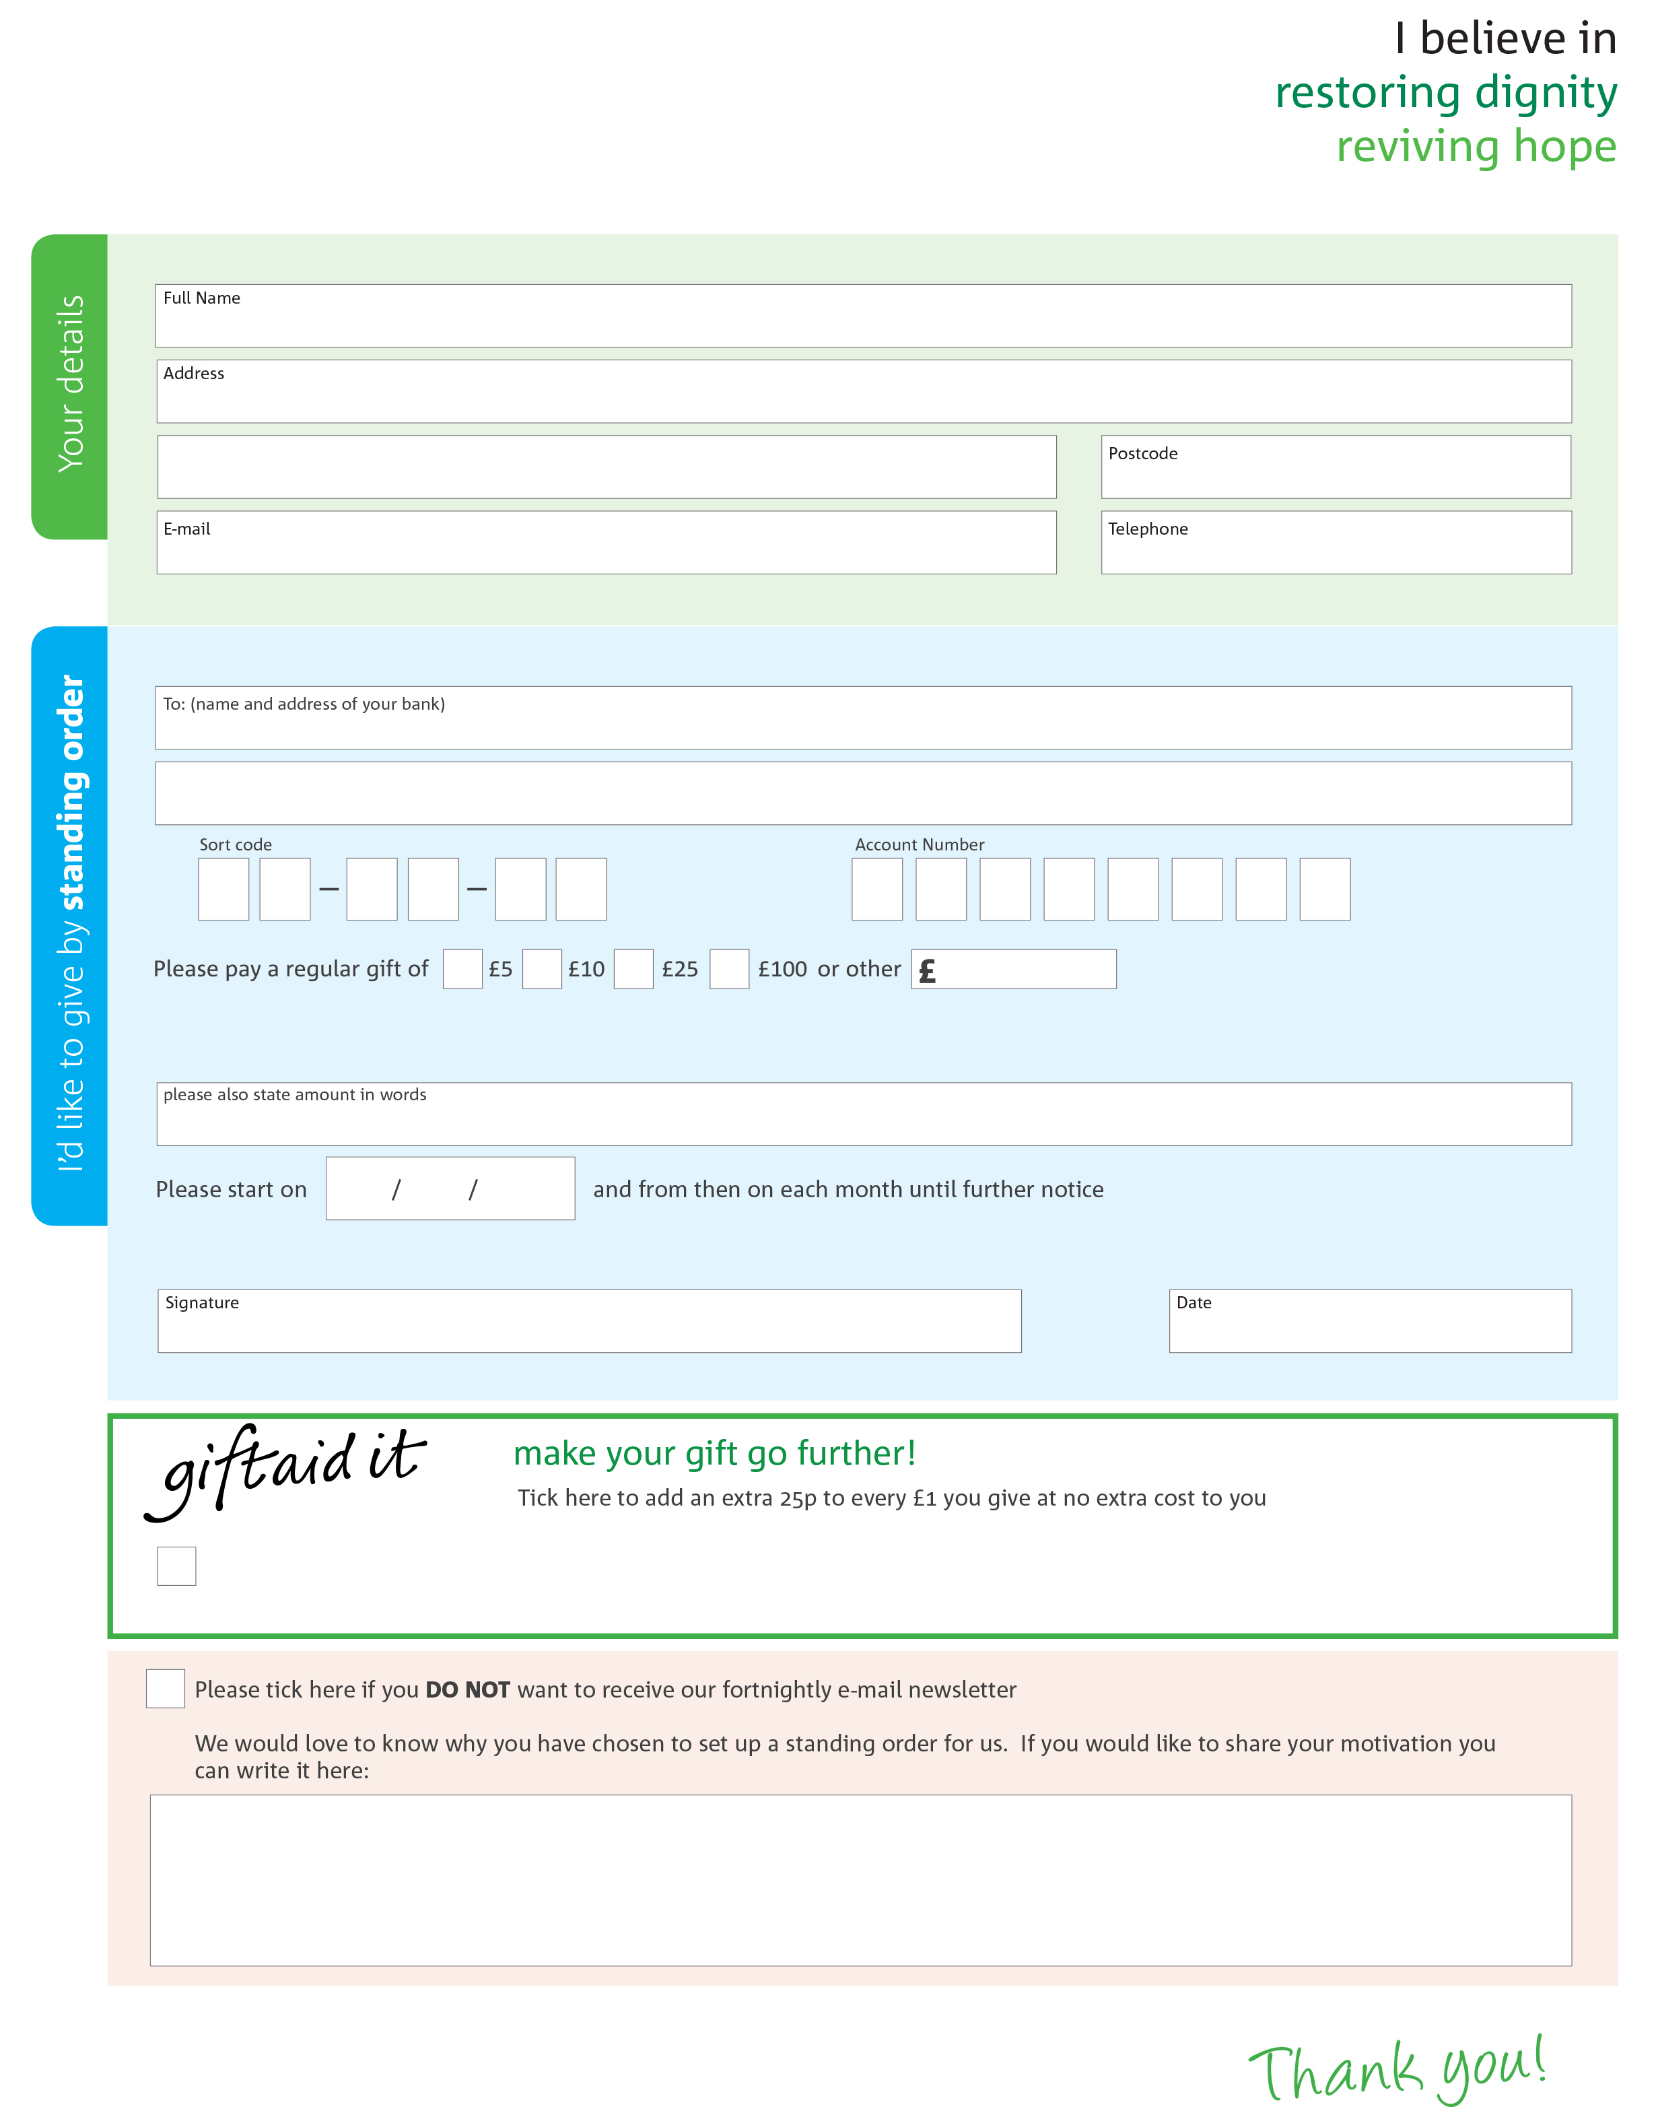

farnworthkearsley.foodbank.org.uk

Facilitated by Farnworth Baptist Church. Reg. Charity No: 1150233 | Reg. in England & Wales

This cancels any previous standing order instructions to Farnworth and Kearsley foodbank

To Farnworth and Kearsley foodbank each month,